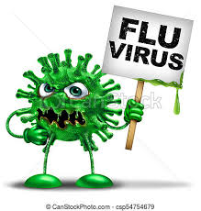
Flu vaccinations
The flu vaccine is being offered to:
- Adults – aged 50 and over (including those who will be 50 by 31st March 2022)
Children - The nasal spray flu vaccine will be offered to:
- children aged 2 or 3 years on 31 August 2021 – born between 1 September 2017 and 31 August 2019
- all primary school children (reception to year 6)
- all year 7 to year 11 children in secondary school

School age children will be offered the vaccine at school.
Unfortunately, if you do not receive an invite to book an appointment for your child we will not be able to offer a vaccination
- children aged 2 to 17 years with long-term health conditions

If your child is aged between 6 months and 2 years and has a long-term health condition that makes them at higher risk from flu, they'll be offered a flu vaccine injection instead of the nasal spray. This is because the nasal spray is not licensed for children under 2 years.
The nasal spray vaccine offers the best protection for children aged 2 to 17 years. They will be offered the flu vaccine injection if the nasal spray vaccine is not suitable for them.

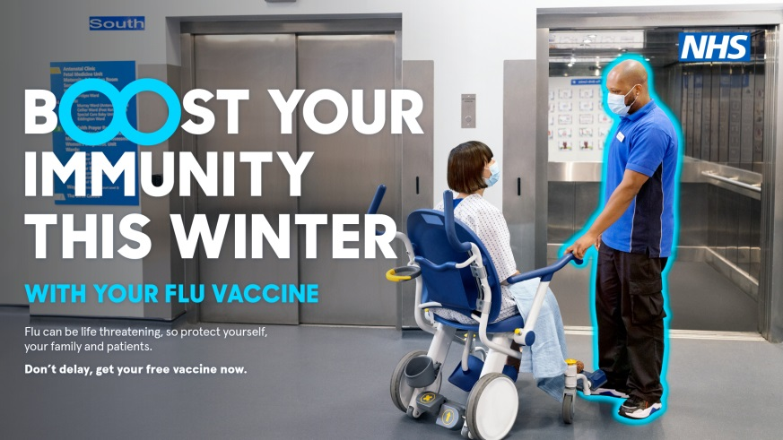
You will be eligible if you have a long term health condition:
- respiratory conditions, such as asthma (needing steroid inhaler or tablets), chronic obstructive pulmonary disease (COPD), including emphysema and bronchitis
- diabetes
- heart conditions, such as coronary heart disease or heart failure
- being very overweight – a body mass index (BMI) of 40 or above
- chronic kidney disease
- liver disease, such as hepatitis
- neurological conditions, such as Parkinson's disease, motor neurone disease, multiple sclerosis (MS), or cerebral palsy
- a learning disability
- problems with your spleen, for example, sickle cell disease, or if you have had your spleen removed
- a weakened immune system as the result of conditions such as HIV and AIDS, or taking medicines such as steroid tablets or chemotherapy

Pregnant women

- Frontline health or social care workers - registered residential care or nursing home
- registered homecare organisation
- hospice
- You can also have the flu vaccine if you provide health or social care through direct payments or personal health budgets, or both

- Carers - someone in receipt of carers allowance or the main carer for an older or disabled person – Please advise reception if you are a carer
- If you live with someone who is more likely to get an infection ( someone who has had a transplant, having certain treatments for cancer, lupus or rheumatoid arthritis)
_________________________________________________________________
There are several types of flu vaccine. You'll be offered the one that's most effective for your age:
- Children aged 2 to 17 in an eligible group are offered a live attenuated quadrivalent vaccine (LAIV), given as a nasal spray
- Adults aged 18 to 64 who are either pregnant, or at increased risk from flu because of a long-term health condition, are offered a quadrivalent injected vaccine – the vaccine offered will have been grown either in eggs or cells (QIVe or QIVc), which are considered to be equally suitable
- Adults aged 65 and over will be offered either an adjuvanted trivalent injected vaccine grown in eggs (aTIV) or a cell-grown quadrivalent injected vaccine (QIVc) – both vaccines are considered to be equally suitable.
- If your child is aged between 6 months and 2 years old and is in a high-risk group for flu, they'll be offered an injected flu vaccine as the nasal spray is not licensed for children under 2.
It's important that you benefit from having the most effective vaccine.

