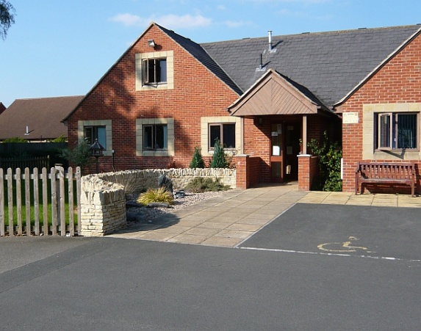

**Practice Team Doctors**

Dr Jeremy Pawley

Dr Simon Hill

Dr Kim Purvis

Dr Sam Cooke

**Practice Manager**

Angela Maile

**Assistant Practice Manager**

Clare McDuff

**Nurses**

Hollie, Alison, Clare

**HCA’s**

Keriann

**Phlebotomist**

Natalie

**Clinical Pharmacist**

Sofia

**Advanced Nurse Practitioner**

Julie

**Advanced Clinical Practitioner**

Suzi

Hina

**Dispensary -** Janice, Lesley, Debbie, Caroline, Diane, Kerri

**Reception -** Anne, Beth, Cher, Caroline, Jayne, Jane, Jo, Tash, Trudi, Sarah

**Normal Opening Hours**

**Surgery**  **Monday to Friday 8:30am – 6:30pm**

**Dispensary Monday to Friday 8:30am – 6:30pm**

**Dispensary Closed for lunch between 1pm – 2pm**

**Surgery Email Address;**

[**HWCCG.bredonhillsurgery@nhs.net**](mailto:HWCCG.bredonhillsurgery@nhs.net)

**Dispensary Email Address, if you need to order medication;** [**HWCCG.dispensary.bredon.hill.surgery@nhs.net**](mailto:HWCCG.dispensary.bredon.hill.surgery@nhs.net)

**Please contact Out of Hours service on 111 if you require urgent assistance outside our opening times.**

**Surgery Staff News**  Congratulations Dr Purvis! - on the birth of your beautiful daughter.

Dr Pygott and Dr Cusack will be seeing Dr Purvis’ patients whilst she is on maternity leave.

Congratulations Janice in Dispensary! for 20 years of service with

Bredon Hill Surgery.

Welcome to the team Hina our new ???

**Appointments -**In these unprecedented times everything at the surgery has had to change. For the foreseeable future we will no longer see patients face to face unless there is a clinical need. All requests for advice or assessment will receive a telephone triage call or video call. Face to face assessments will be conducted with the strictest infection control measures in place.

**Patient Participation Group -**For a number of years the doctors and staff at Bredon Hill Surgery have been supported by a group of patient volunteers who make up the Patient Participation Group – PPG.

The meetings are held on a Monday evening – usually 3 or 4 a year

New members are always welcome and if you would like to know more about what is involved, please contact Cher Pickford PPG Secretary 01684 773444 or SOWOCCG.bredonhillsurgery@nhs.net, or Elaine Cantle, Chairman, 07730 810507 or email [tyler631@btinternet.com](mailto:tyler631@btinternet.com)







****We now offer the opportunity to check your symptoms and **consult with** a **doctor online**. Please visit our website and click on the link

**Advanced Nurse Practitioner (ANP) -** ANP’s are registered nurses who have completed extra training and academic qualifications to be able to clinically assess, diagnose, refer and treat patients. An ANP can assess your symptoms, treat minor health problems, infections and prescribe medication where necessary.

**Advanced Clinical Practitioner (ACP)** - Clinical practitioners are trained specialist nurses who have undertaken additional education in order to provide advanced nursing/medical care. ACP’s can provide treatment including medication and provide medical advice for many problems.

**Other routine appointments**

**Medication reviews** are now being carried out. If you do have any specific concerns with regards to medication please contact reception to make a phone appointment with Sofia Tasleem (Clinical pharmacist) or a doctor.

**Annual Reviews** are now being carried out.

**Smears** – If you had a appointment cancelled in March/April the surgery will be in touch to arrange an appointment.

If you have had a letter from us to advise your smear is due; **please contact the surgery** to book this with a practice nurse.

Please can we request you wear your own facemask/covering.



Baby vaccinations – we are holding clinics at the surgery. You may receive a letter from Child Health to advise your child’s immunisations are due. Please call the surgery and advise you have the letter. The receptionist will tell the nurses who will call you to arrange an appointment. Alternatively you may receive a phone call to book an appointment.

**If you are experiencing difficulties with your mental health, visit the practice website for useful links to the services.**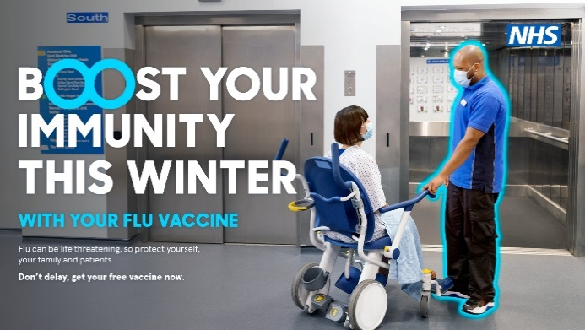

Flu Vaccinations -We are still awaiting delivery confirmation of our Flu vaccines. We expect to hear in the next couple of weeks. We are planning to start Flu clinics from September/October dependent on vaccine delivery. Please do not ring us we will be in contact with you once appointments are available to book. Thank you



[Please visit the website for useful links – providing extra support and details of services.](http://www.nhs.uk/smokefree)